  We’ve Sponsored The  Metcalf Avenue of Flags for 40 years! | November, 2006  The Lions’ Roar  Overland Park Host Lions Club  Overland Park, Kansas  Lionism’s 90th Year 2006-2007 Our 50th Year |   WE SERVE

The Last Observance This Year. . .
Help Fly the Flags Once Again On Metcalf
Flags go up and down again on this Saturday, November 11 in observance of Veterans Day. We need all the help we can get for Flag raising (and lowering). Family members or friends who can help are welcome. Because this is a regular-meeting date, it’s a great opportunity to invite friends to the meeting, as guests and prospective members. (Tell them they’ll be our guests for breakfast.)
Young people who need some community service hours for school credit might respond to a request for help, especially on a Saturday when they don’t have to get to school!
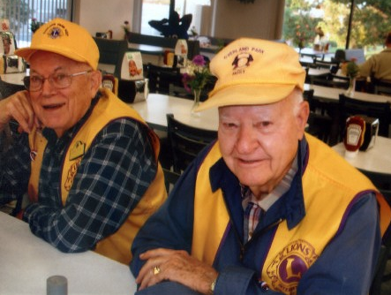
On Columbus Day, October 9, we had breakfast at Hy-Vee, 95th and Quivira. Two hungry Lions—Jack McClain and Dale Warden—smile for the camera as they wait for their food to be brought to the table.
Missouri 26G Lions, Kansas K7 Lions,
Lenscrafters, and Salvation Army To Sponsor Children’s Eye Care Program, November 13-17
Kansas and Missouri Lions, along with Lenscrafters and the Salvation Army will provide a program of eye screening for 500 Kansas City area children each day during the week of November 13-17. Two work shifts each day are scheduled—8:30 a.m. until noon and noon to 4 p.m. Lions’ responsibilities will include supervision of children while they wait for their screening appointments and to get them to the appointments on time.
Big Lion Ken Collyard will remind us about this co-operative work program at our meeting on Saturday.
Tail Twister Returns Us to “Uniform of the Day”
Tail Twister Lion Ron Bloome announces that he is returning us to the “Uniform of the Day” idea, popular in our club several years ago.
For the meeting of November 11, the “uniform” will be the bibs we all received when inducted into the Club. Lion Ron added “if you have them.” Editor’s note: this probably will be interpreted to mean, “if you DON’T have yours or don’t WEAR it if you do still have it, some sort of fine will be assessed.” Consider yourself notified.
Food, Fun, Fellowship, Profit . . . What more could we ask?
Anniversary Fund Grows By Another $1900
With Pasta Supper/Silent Auction, Garage Sale
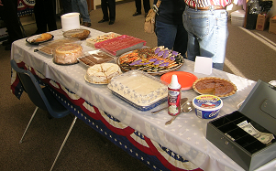
The dessert table before Pasta Supper festivities began on the evening of October 14.. It was nearly empty at evening’s end, but the cash box was nearly overflowing! Dessert sales almost equaled the amount raised in ticket sales for the meal.
What is now hoped to become an annual affair, our first-ever Pasta Supper and Silent Auction on October 14, was a real success. Approximately $900 was raised in the silent auction and another $500 profit was made from the sale of dinner tickets and desserts.
All items for sale in the silent auction were donated by club members, relatives, and friends. There were about 70 items available for adult bidding and another twelve for young children.
Desserts priced at $1.50 each were all donated, mainly by the ladies of our club, and were sold separately from the pasta supper tickets ($5 for adults, $3 for kids).
A crowd of between 80 and 100 persons was in attendance. The 50th-Anniversary Planning Team was very pleased with the turnout and the financial results. Perhaps even more important, however, was that the evening was basically a club and family social. Several spouses, children, grandchildren—even great-grandchildren—attended.
The affair was held in the Fellowship Hall of the Indian Heights United Methodist Church, 103rd and Nall in Overland Park. Lion Chuck Olsen, a member of that church, made the arrangements for us to use their facilities.
Second Garage Sale Helps, Too . . .
Another $540 was raised on the week-ends of October 21 and 28 through a garage sale held at the home of Lions Roger and Mae Claxton. Rainy weather on the 21st forced an early-shut down. Lion Mae scheduled a second try for the following Saturday.
Raffle-Ticket Sales Expected To Be A Success . . .
Additional funding for the Anniversary Dinner will come from the sale of raffle tickets to other clubs in the District and across the state. Several very attractive prizes have been acquired to help create interest in purchasing tickets.
We serve in many different ways . . .
OP Host Lions Serve During Deanna Rose
“Pumpkin Hollow” Fund-Raising Month
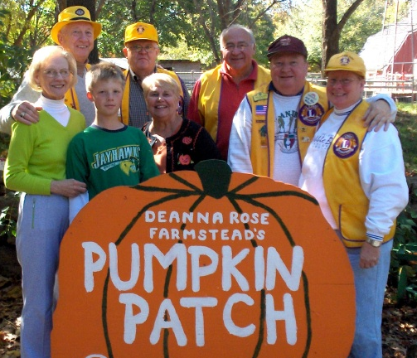
Volunteers representing the Overland Park Host Lions Club (from left) are Joan Olsen, Lion Chuck Olsen, Collin Pettell (grandson of the Olsen’s), Lion Chuck Binau, Terry Meganck, Lion Art Meganck, Lion Larry Martindale, and Lion Janet Sanders-Reh.
Friday, October 20 was an incredibly great, balmy fall day, perfect for volunteering at the Deanna Rose Children’s Farmstead’s “Pumpkin Hollow.” The Pumpkin Hollow is one of the Farmstead’s major fund raisers, which allows the Farmstead to maintain its no admission charge policy.
Families with children were treated to a horse-drawn wagon ride to the Hollow. There they found many activities and games for the children. Before leaving the Farmstead, every person selected a pumpkin to take home.
“It was a rewarding experience for all the volunteers,” said Lion Art Meganck, who coordinated our club’s service.
Virgil Miles, Farmstead superintendent, commented that they couldn’t manage the Pumpkin Hollow activities without volunteers. The volunteers took tickets, sold soft drinks, assisted with the games, helped children on and off the wagons, and generally provided guidance and good cheer.
“It was an excellent was to show our support for this wonderful community asset,” said Lion Meganck.. “We were recognized once again for the service we render for others.”
More typical service . . .
Candy Days Net $704 for Sight Projects
Lion Janet Sanders-Reh reports that donations of $704.49 were made during October 27 and 28 Candy Days. Weather early Friday was rainy and cold, but customers leaving the Wal-Mart store near 119th and Metcalf Avenue were in a generous mood.
Reminder . . . Your old Lion Magazines Can Be
A Membership Recruitment Tool
Membership Chairman Lion Darrell Stone asks that we all bring our extra or duplicate copies of The Lion magazine to the next meeting. He will attach cards to them and deliver them to doctors’ and dentists’ offices for membership possibilities.
Reminders of Future Program Assignments
November 11 Janet Sanders-Reh and Dale Warden
Flag Salute: Lion Schulteis Lions Toast: Lion Pinkston
November 25 Larry Martindale and Dick Ferguson
Flag Salute: Lion Roemerman Lions Toast: Lion Rogers
December 9 Kraig Hickey and Jack Brown
Flag Salute: Lion Starks Lions Toast: Lion Tridle
December 23 Ken Collyard and Ron Bloome
Flag Salute: Lion Turntine Lions Toast: Lion Warden
(Invocation responsibility for each meeting to be announced.)
When planning a program, the two Lions responsible for it should keep each other informed about progress; one Lion should be responsible for “hosting” and introducing the program.
Programs should be 20-25 minutes in length. Time for a short question-and-answer time should be allowed. NOTE: speakers appear at their own expense, without remuneration of any kind, including travel. They are, however, the club’s guests for breakfast. They should not solicit contributions, donations, or political affiliation or support, nor should they offer products for sale as part of any program.
Plan programs as far in advance as possible (a minimum of six weeks is ideal). Until a permanent newsletter editor takes over, give details about your program—including speaker’s name, position, and program topic—to Lion Neal Nichols (913-642-7520) or e-mail to taximath@aol.com.
Always worth repeating . . .
Don’t Forget Heart to Heart Care-Kit Project
Assignment for November: bring a travel-size soap dish on November 11 or 25. Tail Twister Lion Ron Bloome will gently remind you, should you forget.
We’re gathering materials to make disaster-relief packages—“Care Kits”—to donate to Heart to Heart International (which is headquartered right here in Johnson County.) It isn’t too late to make up for July, August, September, and/or October meetings. Bring or send two 1-gallon ZipLoc bags (for July), a new wash cloth (for August), a new hand towel (for September), and a travel-size bar of soap (for October).
The year-long project will include the following additional items:
December: ten Band-Aids (3/4” width).
January: one wide-tooth comb.
February: one small bottle of shampoo.
March: one new, individually wrapped toothbrush.
April: one travel-size tube of toothpaste
May: one crisp new one-dollar bill (to offset shipping costs).
A “work party” will be scheduled for June, at which time the bags will be assembled for sending to the Heart to Heart warehouse in Kansas City, Kansas.
Just a few of the items for sake at the Silent Auction, October 14. Theme baskets were made by Lions Dottie Bloome, Mae Claxton, Carole Collyard, and Beverly Nichols.
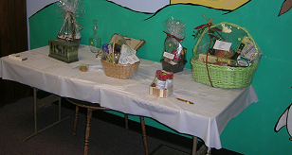
Stark(s) Reality
by Lion Ben Starks
When will it all end?
I’m not talking about the shoddy political campaigns that, fortunately, have come to an end, at least until the next election.
Nor am I referring to the on-going debate about our involvement in Iraq . . .
. . . or the situation in Iran . . .
. . . or the explosion of a nuclear bomb in North Korea . . .
. . . or the horrors of global warming . . .
. . . or the multitude of other problems facing mankind, including cloning.
No!! It’s about that↓!@ construction on 87th Street! When will they ever finish it? One day you can’t get on, the next day you can’t get off, and then again both!! Who has time for all those other “minor” problems when you have this to contend with?
And, of course, common courtesy is out the window. Someone sees a couple-of-blocks-long line of cars in the left lane with a sign saying “Right Lane Closed Ahead,” so they barrel on down the right lane expecting someone to let them into the left-lane line. Do they think their time is more valuable than ours?
Or we have the jerk in the giant SUV, cruising along at 30 MPH in a 45-MPH zone on a one-lane-each-direction roadway, yakking on a cell phone, completely blocking all forward vision . . .
Deliver me from Road Rage!!
So if we do survive road repair, maybe we can elect some sensible people of office.
Some of the things we need from our politicians is a law banning the use of cell phones while driving. We need to eliminate tax-paid pensions to any government officials or workers who become convicted felons! And we need to get a handle on illegal immigration.
All who want to run for office, raise your hand!
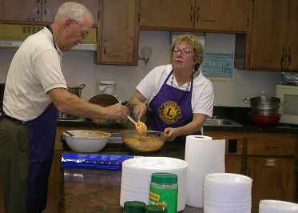
Lions Chuck Olsen weren’t the only members of the kitchen crew, but we see them here getting a batch of spaghetti ready to serve at the Pasta Supper October 14.
See what other Lions around the world are doing to serve humanity.
Go to http://www.lionsclubs.org/EN/index.shtml and click on LQ--Lions Quarterly, the new Lions International video magazine.
Metcalf Avenue of Flags Schedule
May, 2006 through July 4, 2007
Saturday, May 20 Armed Forces Day. Done. Thank you!
Wednesday, June 14 Flag Day. Done. Thank you!
Monday, May 29 Memorial Day. Done. Thank you!
Tuesday, July 4 Independence Day. Done. Thank you!
Monday, September 4 Labor Day. Done. Thank you!
Monday, September 11 Patriot Day. Done. Thank you!
Monday, October 9 Columbus Day. Done. Thank you!
Saturday, November 11 Veterans Day
Saturday, May 19, 2007 Armed Forces Day
Monday, May 28, 2007 Memorial Day
Thursday, June 14, 2007 Flag Day
Wednesday, July 4, 2007 Independence Day
Flags go up at 6:00 a.m., come down at 4:30 p.m.
Meet at Newcomer’s Chapel garage (the “Body Shop”), 82nd and Metcalf.
A special note to other club Presidents and Secretaries who read this newsletter:
District Governor David Hentges’ Awards Program for 2006-2007 includes credit for participating in another club’s projects.
Here’s your chance to earn that credit! Pass the word on to your members. By helping Overland Park Host raise (and lower) the Flags, they will honor our Country, beautify our city, and raise funds for sight-conservation projects—and have a lot of fun doing it with other Lions!!
Special Notice . . . Major Lions Events
K7 District Cabinet Meeting, Zone 4 Meeting
Scheduled: November 11 and November 20
Two important District and Zone meetings are scheduled for the next couple of week and as many members and officers as possible should plan to attend.
(1) K7 District Cabinet meeting, Lawrence, November 11 (run over there after Flags and our regular meeting that morning).
(2) Region 4 Combined Zone Meeting, Tuesday, November 20, 2006. The Olathe Lions Club will host this meeting, which will be held at Olathe Holiday Inn, 151st Street and I-35.
Dinner will be served at 6 p.m., and the meeting will begin at 6:30. Dinner cost is $11 per person. Call Lion Dan Hamblin at (913) 764-2365 to make reservations or send him an e-mail at dan.hamblin@olathelionsclub.org.
A Zone Meeting—especially a combined meeting that brings together all 12 clubs in the region—is an excellent opportunity to meet and fellowship with other Lions and to get new ideas about projects, fund-raising efforts, and general club news around the district..
RSVP right away to Lion Hamblin.

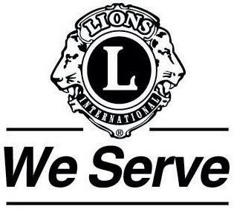
Focus on Membership . . .
The Big Lion’s Message for November
By Ken Collyard, President
Not too long ago, I had a mental awakening or vision regarding the difficulties of membership. Perhaps the best way to describe it is through a parable.
When I was in my early 30s, I was an Analytical/Biochemist teaching in the Department of Entomology at Colorado State University. I was the most popular professor there because of my industrial background. All others professors had earned their PhDs and had gone directly into teaching. I, however, had gone started in industry and developed a diverse background, including involvement in basic research. I was able to relate my students’ professional goals to the outside world, not just academics.
I brought into the department analytical tools such as gas chromatographs and mass spectrometers. I help design olfactometers, tools that are used to determine pesticide levels for insect control.
Talk about a paradigm shift! We went from just a “ho-hum” department to become the talk of the University.
My point is this: I in my early 30s and my students in their late 20s clicked because we were both on the same platform level (to use a modern phrase).
In many cases today, we see that the younger generation doesn’t take much advice from their parents’ generation seriously. The children generally have a lot more computer knowledge and often a higher level of education. They probably think, “After all, our parents can’t run computers as well as we do; therefore their advice must be out of date, too!” Young people these days seem to look to the older generation to console them, love them, and to be a source from which they can borrow money.
WOW!! What a vision, if this is true.
So . . . here we are . . . an older Lions Club now, a club with a vast amount of knowledge in many fields and a range of experiences that our children cannot even fathom. If there is that much space between the younger generation and us, it’s not hard to see why they wouldn’t want to join Lions and participate in what we consider to be very successful projects.
Perhaps our club’s emphasis should be on either a branch club, utilizing their ideas for raising funds, or a new club (which would require 20 members or more). A new club could include younger members—all pretty-much in the same age range—and they could formulate their own methods and projects for raising money.
In my classes I helped students relate their professional goals to the real world. As Lions, we must find methods to help younger generations—boomers, X, Y, and “nexters”—learn how to serve from their “platform level.” If we are open to change sufficiently to let them do things in ways that are new and different from what we always done, we might just find them willing to become Lions with us.
Jimmy Ross, president of Lions International for this year, has said that the older generation “can be and are an asset to Lions.” A pronounced sense of our own innate being is to serve. The elderly and the younger generation together are vast reservoirs of talent.
I hope we can brainstorm these and other ideas to develop ways of making a membership-growth program work.
Wear Your Pin With Pride!

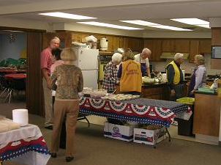
Lion Dottie Bloome (far right) looks as though she’s telling Lion Tail Twister Ron either to get busy or to get out of the way while others are working. The kitchen team had a well-organized, efficient serving line and guests at the Pasta Supper, such as those shown below, didn’t have to wait in line too long.
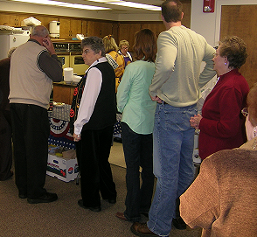

The 2007 USA/Canada Lions Leadership Forum will be in Grand Rapids, Michigan, September 6-8. Plan now to attend. Early registration means a better chance to get assigned to the hotel of your choice. The Forum is a tremendous opportunity to enhance your skills as a Lions leader—present or future! Kansas’ own Past International Director Ed McCormick is general chairman for 2007.

The Overland Park Host Almanac . . .
(More than you ever wanted to know about anything!)

2006-2007 Officers and Board of Directors
Overland Park Host Lions Club
Ken Collyard President
Mae Claxton Immediate Past President
Merlyn Albaugh 1st Vice President
Ed Schulteis 2nd Vice President
Beverly Nichols 3rd Vice President
Carole Collyard Secretary
Roger Claxton Treasurer
Pat Gray Lion Tamer
Ron Bloome Tail Twister
Dick Ferguson Director, 2004-2007
Grant Rogers Director, 2004-2007
Jack McLain Director, 2005-2008
Art Meganck Director, 2005-2008
Paul Roemerman Director, 2006-2009
Chuck Olsen Director, 2006-2009
Darrel Stone Membership Committee Chair
Dottie Bloome Membership Committee Vice-Chair
Bob Larson Membership Committee Member
District K-7 Officers
David Hentges (Turner) District Governor
Neal Nichols (Overland Park Host) Vice District Governor
Richard Barnes (Shawnee) Secretary
Rick Dodson (Lansing) Treasurer
Bernard Lee (Scranton) Immediate Past District Governor
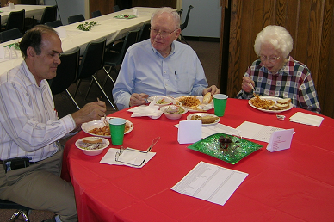
Pictured above are Big Lion Ken Collyard, Past District Governor Lion Frank Piepenbring and Inez enjoying platesful of spaghetti, meatballs, and sauce at the Pasta Supper on October 14.
Condensed Treasurer’s Reports
(October, 2006)
General Operating Account
Income:
50th Anniversary Account (all sources) $ 2,176.33
Meals 748.00
Membership dues 475.00
Total Income $ 3,399.33
Expenses:
50th-Anniversary Celebration expense $ 774.22
Supplies/Miscellaneous 74.61
Meeting room/meals 648.60
OPHLC Endowment Fund 500.00
Total expenses $ 1,997.43
Net Income $1,401.90
Service Account
Income:
Flag sponsors $ 1,158.00
Candy Days 704.49
Overland Park Arts and Crafts Festival 4,092.77
Total Income $ 5,955.26
Expenses:
Deanna Rose Garden Project $ 365.20
Eyeglasses for indigent persons 115.00
Overland Park Arts and Crafts Festival 309.80
Total Expenses $ 790.00
Net income $5,165.26
For your calendar . . .
Sat., November 11 Metcalf Avenue of Flags up, 6:00 a.m.
Regular meeting, Wyndham Garden, 7:00 a.m.
Metcalf Avenue of Flags down, 4:30 p.m.
District K-7 Cabinet meeting, Lawrence, 9:00 a.m.
Monday, November 20 Zone Meeting, Olathe, 6:00 p.m.
Holiday Inn, see details on page 3 of this issue.
And later on . . .
January 12-14 Kansas Lions Mid-Winter Rally, Salina
We will have a hospitality room at the Salina Holidome to sell raffle tickets for our 50th Anniversary. Plan to attend and help out! Anyone for a fried-chicken Sunday dinner at Brookville Hotel (now in Abilene) on the way home?
March 2-3, 2007 K-7 District Convention, Kansas City, KS
May 4, 2007 Fiftieth Anniversary Banquet
Overland Park Convention Center
June 1-3, 2007 Kansas Lions State Convention, Hutchinson
International President Jimmy Ross will speak—in person!
July 2-6, 2007 Lions International Convention, Chicago
Join the 90th Anniversary Celebration in the Windy City!
September 6-8, 2007 USA/Canada Lions Leadership Forum
Grand Rapids, Michigan

Submit all information for publication in The Roar no later than Tuesday after the first Saturday of each month. Submit by e-mail to taximath@aol.com and put “OPHLC Newsletter info” on the subject line. If you don’t have Internet access, send by US Mail and then call (913) 642-7520 and leave word that you’ve sent some material.

